Route Randa  Group 1  Pto Pollensa –(through town and main road) Pollensa – Lluc – Selva  Group 2  Campanet Lane - Right in Campanet. Follow the road coming out at bottom of Moscari hill; right then 100metres right again to Caimari; care, easy to miss. Caimari left to Selva  All groups  Selva – Inca (possibly using bike lane from Selva) – right onto main road at first roundabout – left at second roundabout towards Sineu – turn right along Water Lane until T junction with Sencelles road – turn left to Sencelles – Algaida – main road towards Llucmajor – turn left to Randa – through village up climb to Randa to Monastery  Randa – Montuiri – (take great care in Montuiri to get the left turn in the middle of town towards Lloret, it’s easy to miss) Lloret – Sineu – Llubi – Sa Pobla – marshes – Alcudia – Pto Pollenca.  Comment  Note that for the true enthusiast there is an extended option to take in San Salvador as well. | 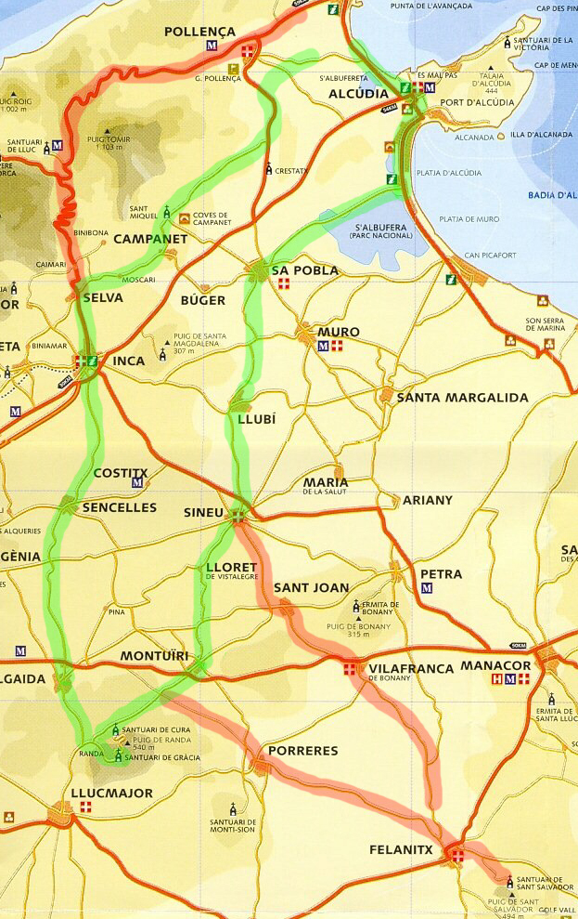
Route Son Serra  All Groups  Pto Pollensa - Pollensa (via back lane, main bay road, Golf Club, as selected by ride leader)  Group 1  Campanet – Buger – Sa Polbla  Group 2  Sa Pobla.  All groups  (At Sa Pobla fFollow new ring road to the left. At the junction with the Muro road, turn right towards the town, take first left to join Llubi road where turn left. This cuts out the town centre) – Sineu (at Sineu turn left to skirt the town; as the road swings round to the right take the first left turn to Petra) – Petra – down the big hill to Son Serra.  Santa Margalida – Llubi – Sa Pobla - via marshes to Alcudia - Pto Pollensa | 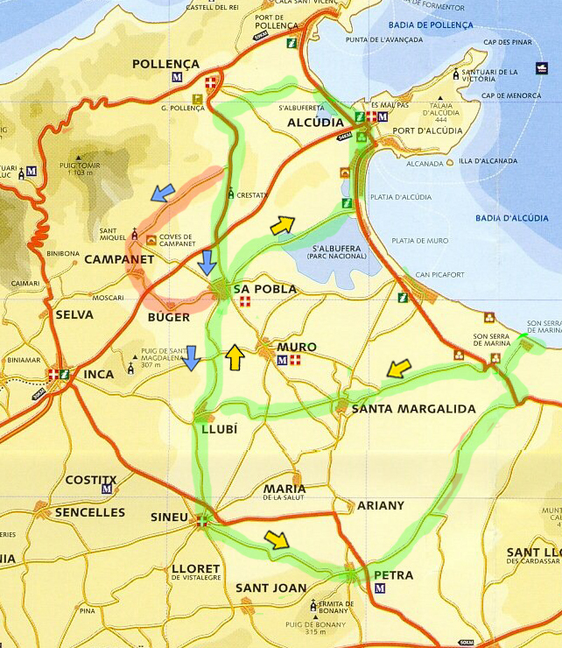
Route Santa Maria  Group 1  Pto Pollensa (through town, main road ) – Pollensa – LLuc – Selva –  Group 2  Pto Pollensa – Pollensa (using back lane) – along bumps – right into Campenet lane– Moscari – Selva –  All groups  Lloseta (there’s a complicated junction here; of the 2 roads more or less directly opposite, take the leftmost (higher up) to avoid the town centre) through town and right at bottom of hill towards Biniamar – Alaro – Orient – Bunyola– Santa Maria (café is Ca’an Kalet in town center, other side of the road as you approach from Bunyola)  Santa Maria – (to get to Water Lane go out of Santa Maria take 1st right to Sencelles; take 1st left (in some houses); take care, easy to miss) – Sa Pobla – bumps – Pollenca – Pto Pollensa | 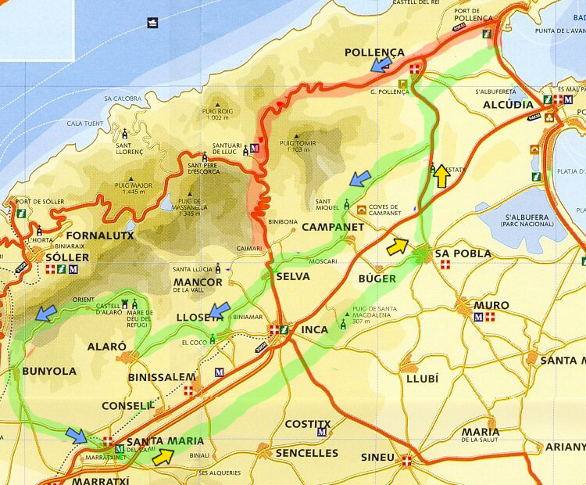
Route Sineu  All Groups  Through Pto Pollenca – bumps road – Sa Pobla – Can Picafort – Santa Margalida – Llubi - Sineu  Group 1  Sineu – (quarry road to) – Petra – descend to coast road – Son Serra – Can Picafort  Group 2  Maria – Santa Margalida – down to coast road – Can Picafort  All Groups  Alcudia – round the bay – Pto Pollensa | 

